**App Service Migration**

**Step1**

Download the sample project from the following link

<https://github.com/Azure-Samples/dotnet-sqldb-tutorial/archive/master.zip>

**Step2**

1. Open the ***dotnet-sqldb-tutorial-master/DotNetAppSqlDb.sln*** file in Visual Studio
2. Create SQL Db and replace the connection string in web config

**Step3**

Run the Application **Ctrl+F5**

The app is displayed in your default browser

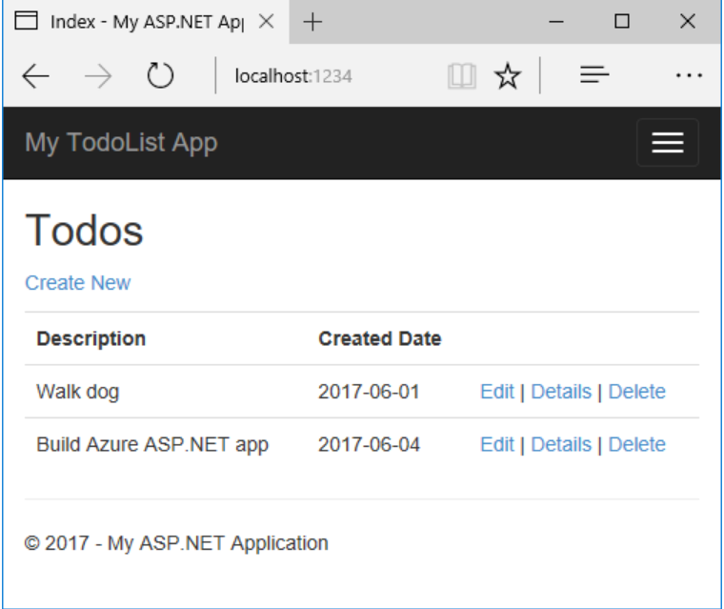

**Step4**

Publish to azure with SQL DB

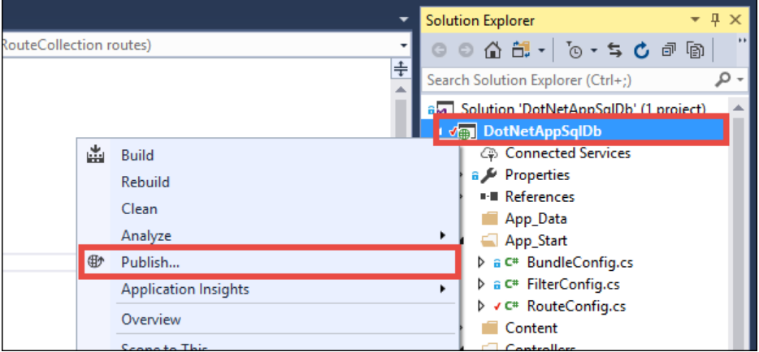

**Step5**

Make sure that **Microsoft Azure App Service** is selected and **create New**

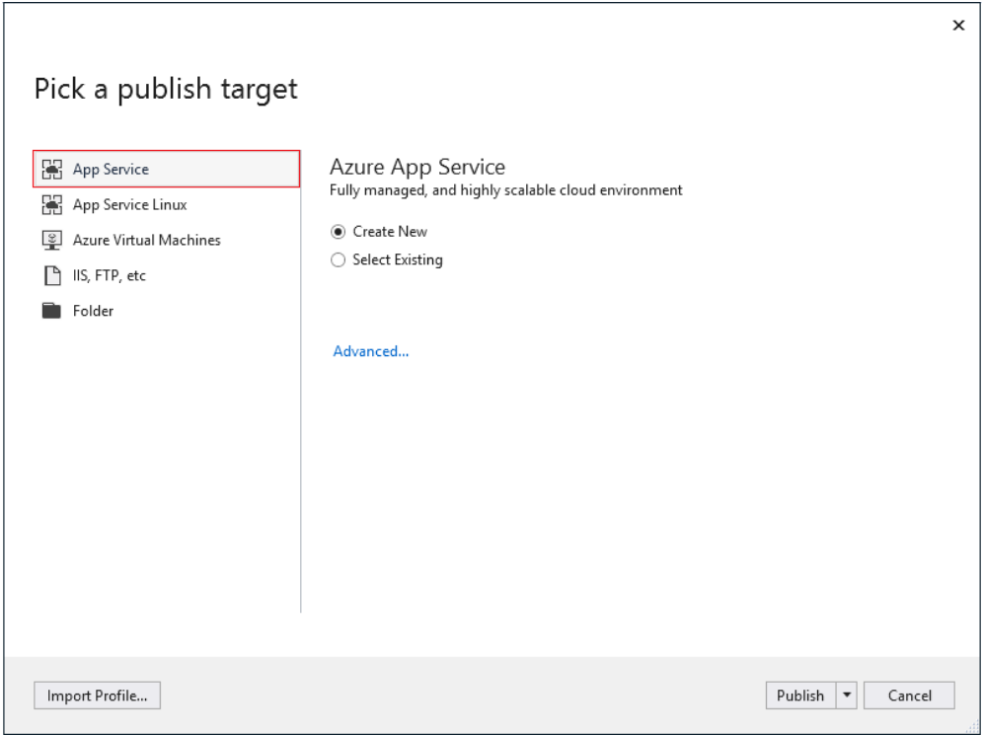

**Step6**

Sign into azure account

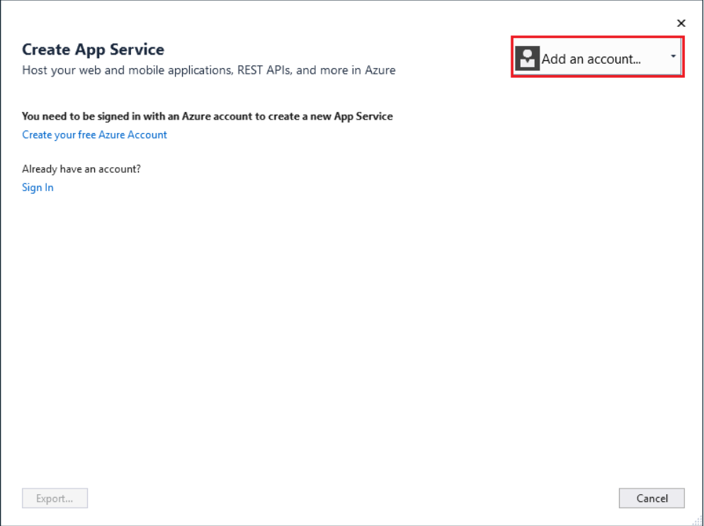

**Step7**

Configure the **web app name** and **resource group** and **app service plan**

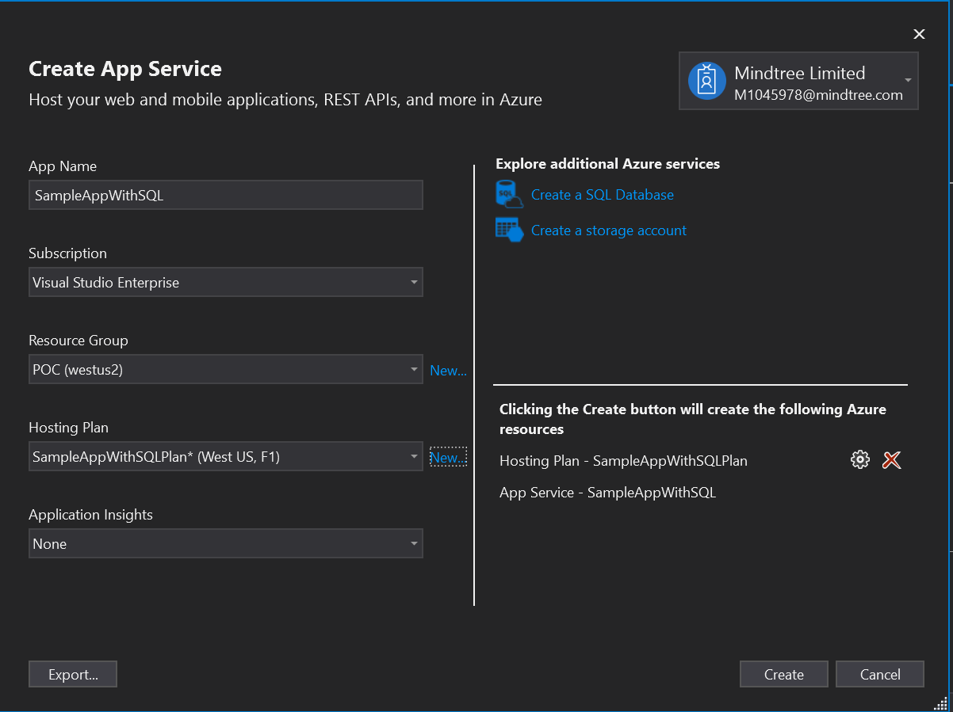

**Step8**

Create SQL server instance and SQL Database

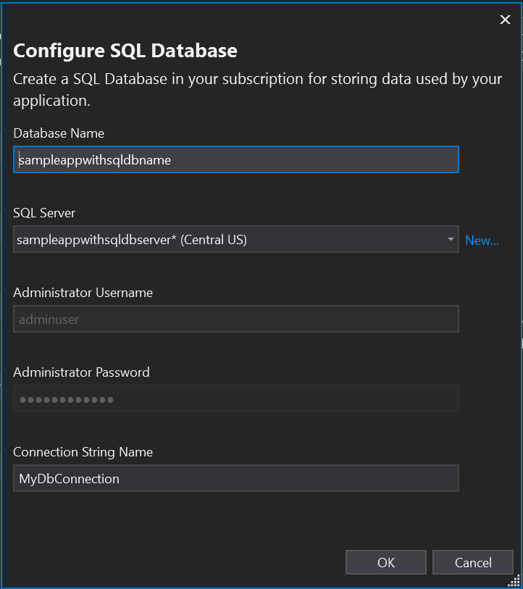

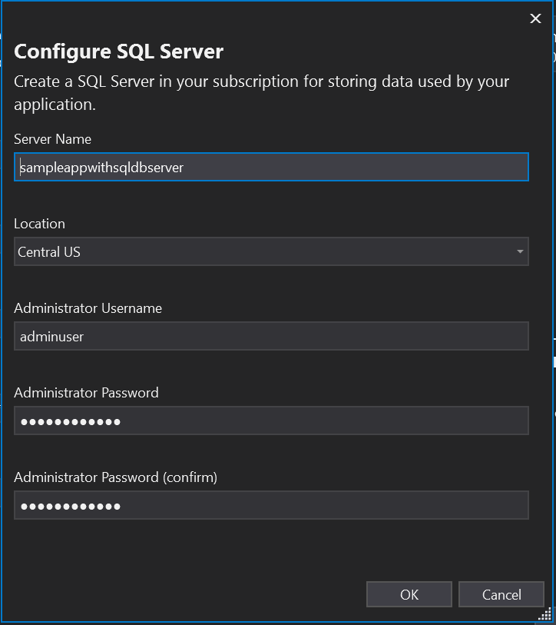

**Step9**

Once you clicked publish, it will take few minutes to publish and opened the browser

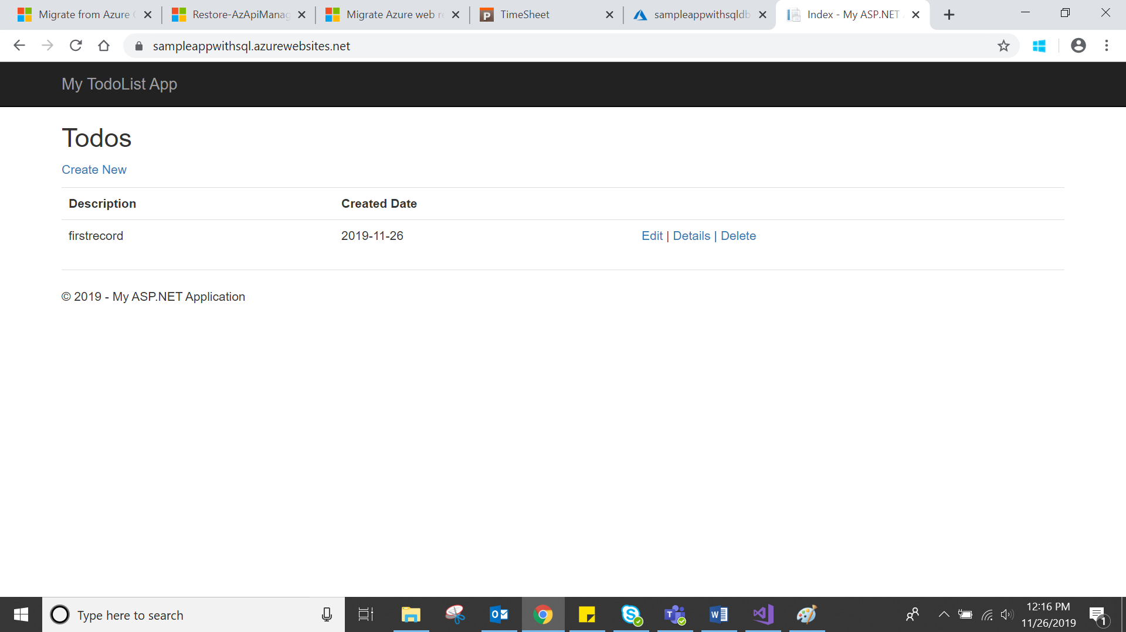

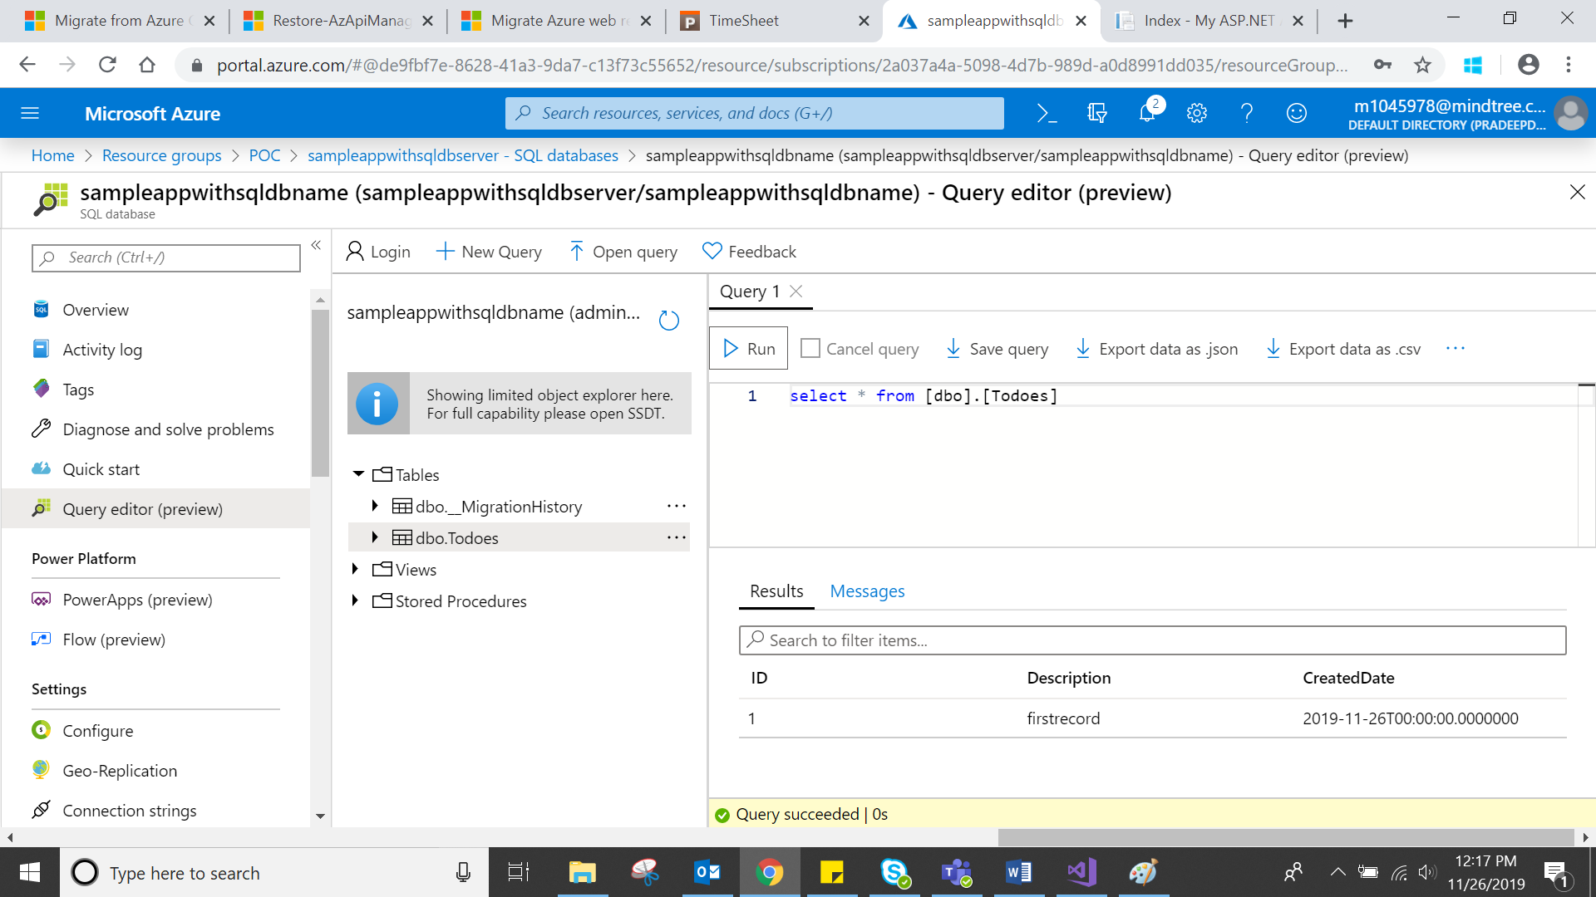

**Step10**

Go to azure portal and check the app service what you have published

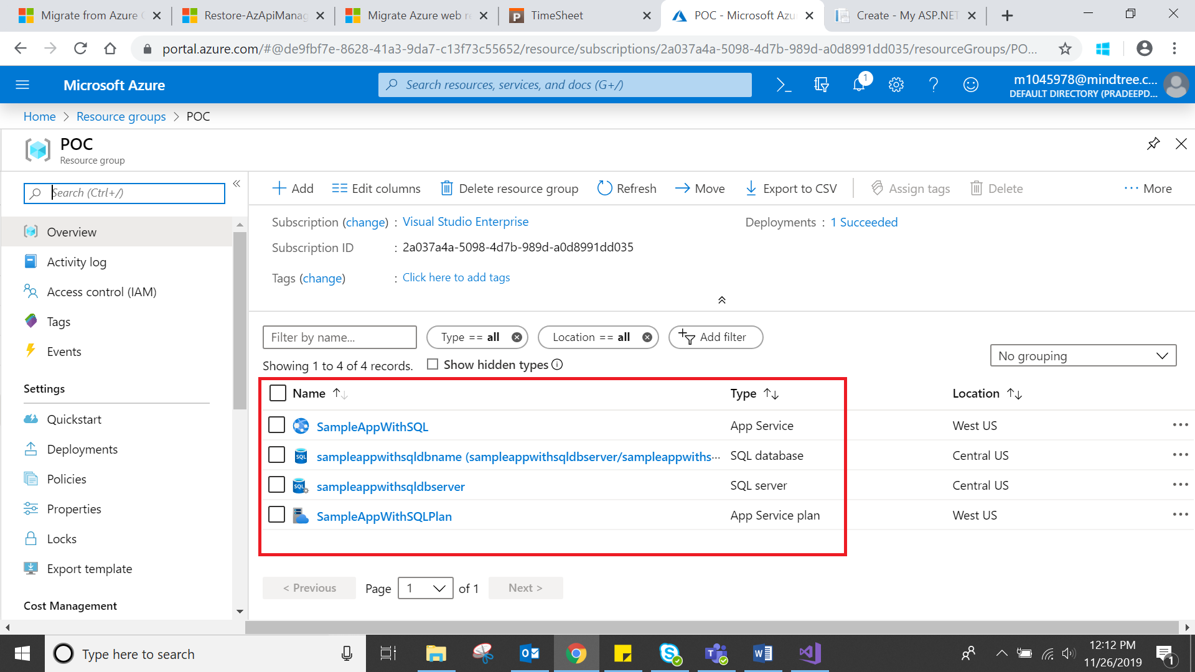

**Step11**

Download the source code as ZIP format from KUDU console in app service( what we deployed)

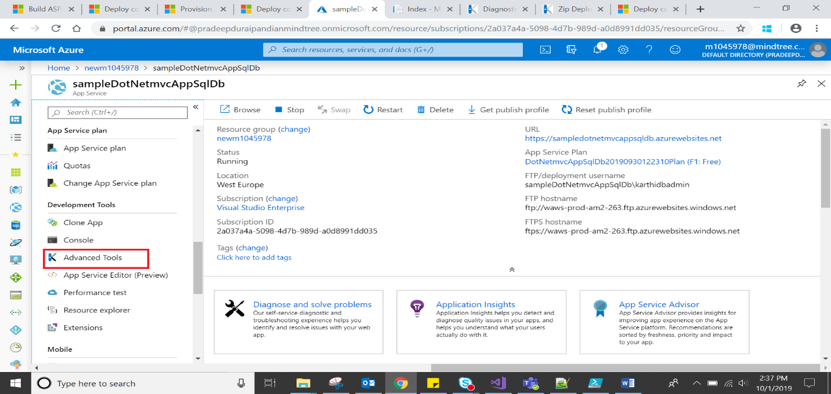

Go to Debug Console🡪CMD🡪site🡪wwwroot🡪click download symbol

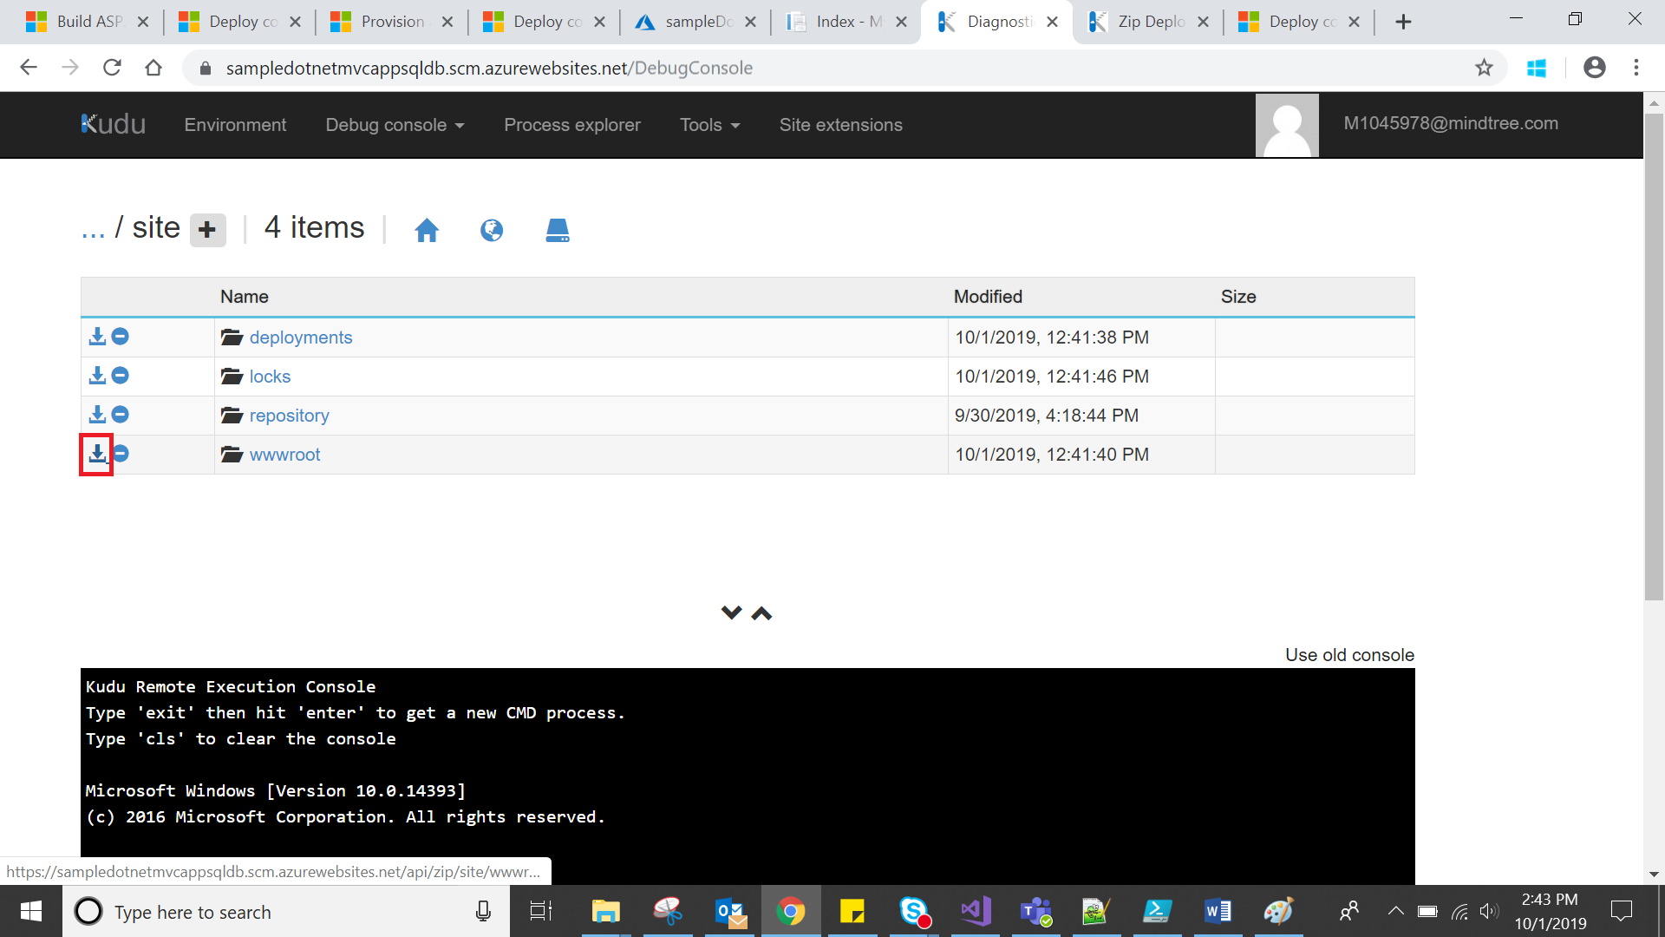

**Step12**

Create one more app service and app service plan using ARM Template

To Download ARM Template select the **App service** and **App service plan** 🡪Click, **more** on Right side corner🡪Click **Export Template**

Create New **SQL Database** to connect with Exported App Service

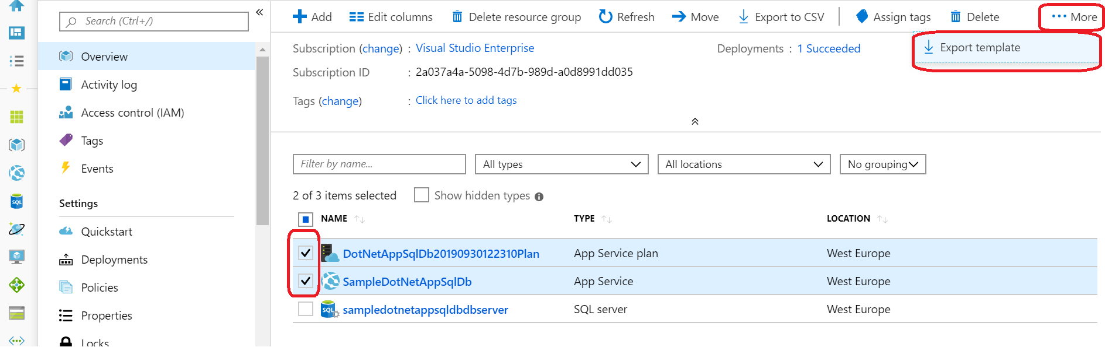



**Step13**

Go to azure portal and check the created app service and app service plan

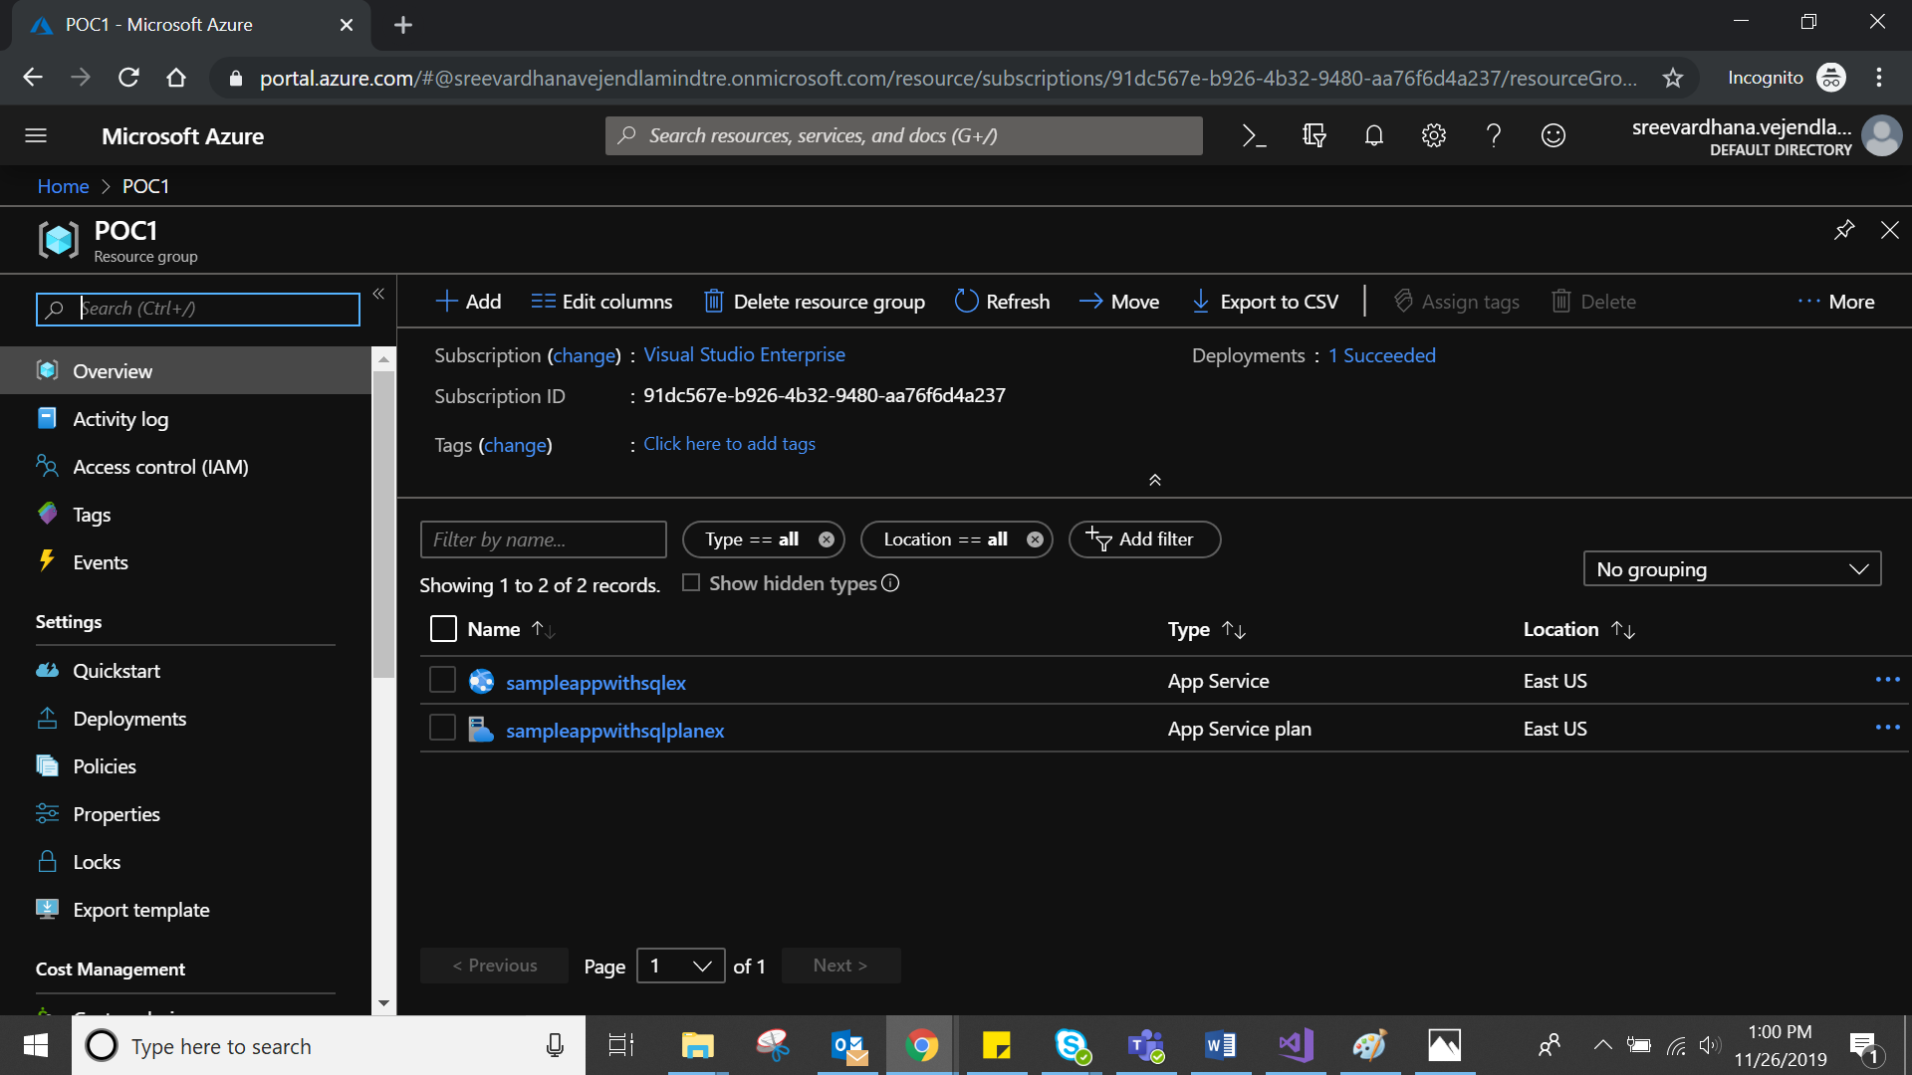

**Step14**

Deploy the ZIP file to App service using PowerShell

Make sure your Azure CLI version is 2.0.21 or later

To see which version you have, run **az --version**command in your terminal window

**az webapp deployment source config-zip --resource-group “myResourceGroup” --name “app_name” --src “path”.zip**

**az webapp deployment source config-zip --resource-group “M1045978” --name “karthisampleapp” --src “C:\Users\M1045978\Downloads\wwwroot.zip”**

**Step15**

Check the new app service using KUDU console and open the app service URL

This command deploys the files and directories from the ZIP file to your default App Service application folder (\home\site\wwwroot)

Note: change the DB connection string from Old DB to New DB in Web Config

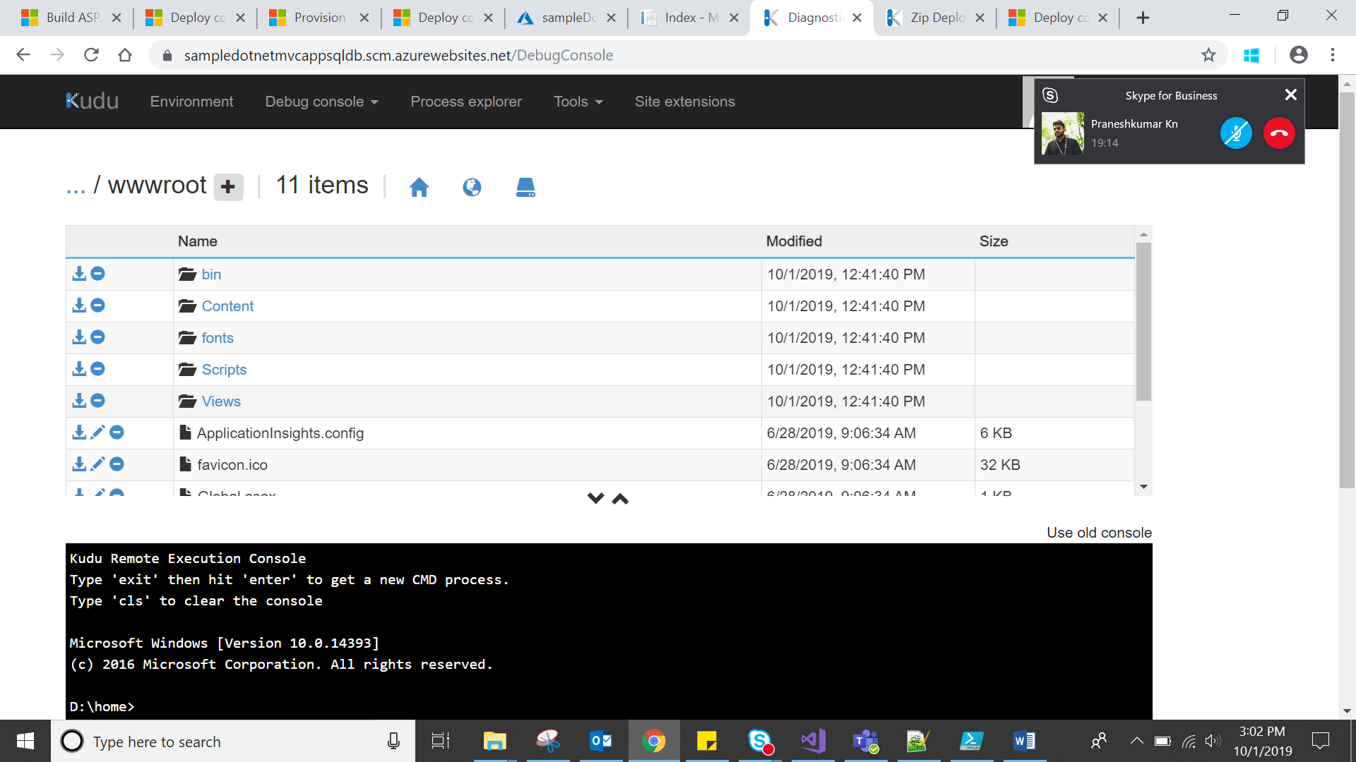

**Step16:**

Browse the exported app service and you will get the home page

Note: If you get any error, Add the IP Address in Firewall settings

